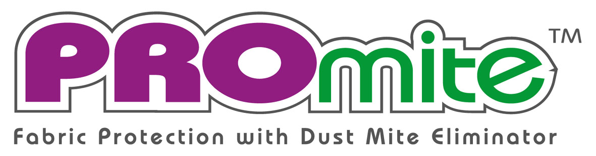
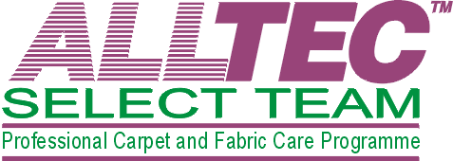

Protection Against The House Dust Mite
An Introduction To PROmite™

For Allergy Control

Item

Testimonials Of PROmite™
“Your treatment of my mattress and carpet has given me much relief during the night, so now my mornings start a lot better and I have no need to reach for my inhaler before my day begins”.
Yours trouble free at night
Doreen Cowling

“Since the bedroom carpet and mattress was treated with your PROmite product about two months ago I have had no more attacks and my asthma seems improved.
I was also concerned that the product you use might trigger an allergic reaction, but there were no side effects that I noticed at all.”
Yours Sincerely
H.J.Burkitt

“My sons Asthma has virtually disappeared, he has only used his inhaler 2 or 3 times and his Ventolin has stayed in the medicine cabinet since treating our beds and carpets some 7 weeks ago.
For myself when I awoke for the first time after treating the bedroom I found that I could breath freely with no wheezing.
I recommend PROmite without hesitation…”
Andrew Hough
16
Are You Putting Your Family’s Health At Risk?

If you think your children, or you, don’t have an allergy I suggest you read this booklet or contact the British Allergy Foundation.

Over 50% of children have some form of allergy, unfortunately for most of them the symptoms will not be diagnosed until they are fully ‘sensitised’ to that allergy – by which time it could be with them for life.
Just a few of the many Testimonial letters we receive from happy customers that have had their lives improved by using PROmite™
Provided As An Education Service By:

Your Name
Company Name

Item

1
The Concept Of PROmite™
Asthma is one of the worlds ‘fastest growing’ illnesses. It affects as many children in the Highlands of Scotland as it does in our inner cities – we asked why?

Item

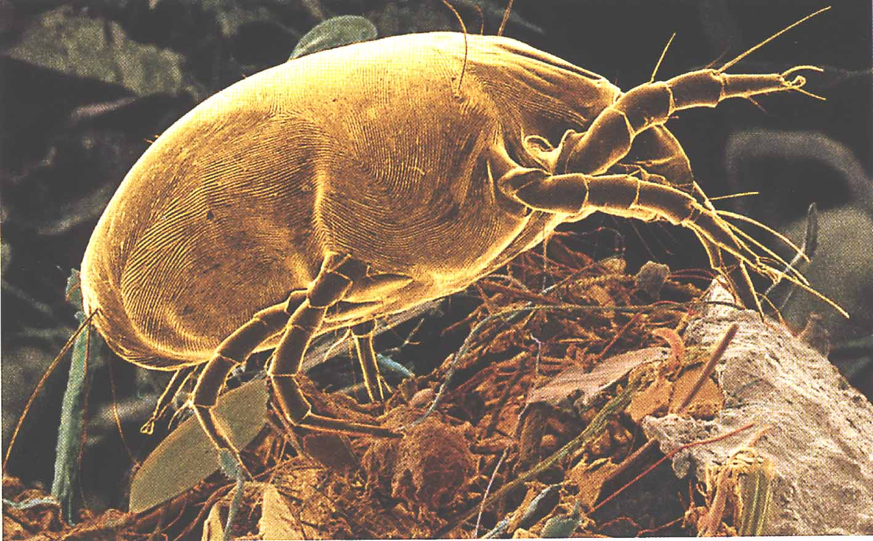

Over the years the professional carpet and upholstery cleaning industry in the UK has been classed as a ‘Mrs Mop’ industry. Seen only as the remaining option to remove stains from years of wear and tear - carried out by untrained people with low-tech equipment.

In countries such as America, Canada and Australia where they have acknowledged professional cleaning for health benefits, it has become customary for homeowners to clean all their carpets on a regular basis.

Everyone is aware that healthy living has become a big issue in recent years. We have removed the smog and improved the pollution that hung over our cities a few decades ago. Factories have strict laws governing the amount of pollution they can exhaust into the atmosphere, even cars are monitored for their emissions.

However, the one environment that we spend the most time in is completely ungoverned and in many cases contains many times more pollution than factories are allowed to exhaust. This environment is the one that is increasing the number of Asthma and allergy sufferers each year, especially in our young children – and it is the one that we believe is safe as it’s the one we call HOME.

Something needs to be done to improve our Microenvironments.

7 Benefits Of PROmite™
Here are just a few of the main benefits for you and your family when you have PROmite™ to protect your home.
- Unique formulation, clinically tested and approved treatment - free from biocides

- Totally non toxic and safe for your young children and your pets to play on

- Test results show an almost immediate 100% success rate at eliminating house dust mites

- PROmite™ continues to stop mites from living in your mattresses, carpets or upholstery for up to 10-14 months – keeping your family safe

- British allergy foundation ‘seal of approval’ to show PROmite™ is friendly to allergy sufferers

- Free PROmite™ consumer awareness help-line on 0800 092 0767 for free advice

- Independent testing shows dramatic reduction of asthma and other allergy’s when used as an allergy control programme

14
3

Item
Our Microenvironment
It’s the change in our microenvironments over the past couple of decades that have caused more health concerns than any other time in the past 150 years!
We spend on average a third of our life in our bedroom - just think about all the time you spend breathing in the same contaminated, stale air.

The House Dust Mite is the cause of the biggest source of respiratory allergies for young and old alike, but why is it only now that this problem is brought to our attention – not before?

This is due mainly to the 1970’s energy crisis. Ever since then buildings, both at home and at the office have continued to be designed to save energy. Most buildings today have central heating systems and double glazed windows to seal in the warmth, some even with central air conditioners.

The three main things we need to do:
- Ventilate all bedrooms – especially children’s bedrooms to reduce humidity and prevent Mites from breeding.
- Mechanical Removal – eradication of dead skin and mite faeces by vacuum cleaning with water filtration machines.
- Periodic Professional Cleaning – to dispose of all the unwanted pollutants that are held in your soft furnishings.

Your home furnishings, such as carpets and upholstery fabrics, are a major benefit to you as they act like filters and help reduce the amount of particles in the air, however if they are not professionally cleaned on a regular basis (6-12 months) they may become a source of allergies.

Item

Independent Testing Of PROmite™
Although our test results were great – we called upon the leading body in testing the House Dust Mites – The Medical Entomology Centre, Cambridge.

At the advice of specialists samples were sent to the Medical Entomology Centre, Cambridge (formerly part of Cambridge University) for testing.

The team at the Medical Entomology Centre, Cambridge, which is headed by Dr John Maunder, is regarded by many as some of the leading experts in the field of allergies caused by the House Dust Mite.

The tests were carried out at different levels
of activity to allow differing carpet pile
weight and thickness of fabric. The tests were
mainly conducted over two week periods. The
results were amazing as we had achieved
100% Mite Inhibitor Rate (MIR) well within
the two first two weeks – in fact almost immediately.

It was proven that PROmite was far more beneficial than the Biocide products that are available in both the immediate and long term effects.

Further tests have been carried out to ensure the long-term effects of PROmite™ - No other product has come close to matching these results.
12
5

Item

Item

10
7
- The British Allergy Foundation has described Asthma as “the most common chronic childhood medical condition.” However, no one has ever found a ‘cure’ for Asthma.

- The number of Allergy Sufferers is growing dramatically in the UK. This has been blamed on hundreds of different reasons like pollution. If this was true why is there as many sufferers in the Highlands of Scotland as in the inner cities.

- It is our children that suffer the most. However, millions of pounds are lost in production when people in classrooms and offices become ‘ill’ with headaches tickly throat, runny nose and sore eyes etc…

- We have scientific proof that is not just Asthma, rhinitis and eczema that are caused by the faeces of the Dust Mite – allergies can start as simply as a tickly cough, runny nose and sore eyes etc…

- PROmite™ is a unique new product that is clinically tested and proven to create an allergy-free home environment by safely removing the House Dust Mite from your mattress, carpets and upholstery. PROmite™ a Patented product, unlike most methods – it actually removes the mite, not just the food source and protects your furnishings from soil and stains.

- Some people will tell you to remove your carpets and vacuum with a conventional (bag or cyclone) cleaning machine. This is not correct advice. To transform your life you first need professional advice, professional ‘deep’ cleaning and PROmite™ protection.

- PROmite™ application is only available by trained Professional Carpet and Upholstery Cleaners from the ALLTEC SelectTeam™.
7 Facts About Allergy’s
How We Breathe
The UK government spent millions of pounds on reducing traffic pollution, but found Asthma is still affecting more and more children every year!

Asthma is not the only respiratory illness, nor the only allergy caused or increased in the home - in fact there are hundreds of different allergies. Nevertheless, Asthma is the most serious as it’s the cause of over 2,500 deaths every year in the UK.

As we breathe, air is taken down into the lungs by the windpipe, then into the Bronchi. The air finally reaches the Alveoli where it exchanges the Oxygen in the air for Carbon Dioxide. This process allows the body to function normally. We breathe thousands of times a day without us thinking about it – even as we sleep.

However, if a piece of food became stuck in a Bronchi tube -say a peanut - the brain will send a signal to the muscle in the outer wall to reduce the tube size.

The brain will then produce a cough (or choking) and due to the reduced diameter of tube it will dramatically increase the air pressure – to remove the stuck object.

The inner lining of the Bronchi tubes are covered with damp mucus, which is not normally affected by fine particles. The Mucus is produced in the lung and is moved up the Bronchi by millions of fine hairs that line the wall. This keeps the lungs clean of particulate.
Item 1
The Concept Of PROmite 3

Item 2
Our Environment 4

Item 3
Our Microenvironment 5

Item 4
The British Allergy Foundation 6

Item 5
7 Facts About Allergy’s 7

Item 6
The House Dust Mite 8

Item 7
Facts About The Mite 9

Item 8
How We Breathe 10

Item 9
Asthma Explained 11

Item 10
Independent Testing Of PROmite™ 12

Item 11
Stain Protection Benefits Of PROmite™ 13

Item 12
The Main Benefits Of PROmite™ 14

Item 13
7 Reasons Why It’s Time You Should Use A
SelectTeam™ Member 15

Item 14
Testimonials 16

Table Of Contents

Item
Page No.
15

Working To A Code Of Ethics - Only SelectTeam™ Members have guaranteed your companies continued quest for education to create a ‘Healthy Home’ with help of the British Allergy Foundation.

Use Of PROmite™ - Only SelectTeam™ Members can use the unique House Dust Mite eliminator, which has been independently tried and tested.

New ‘Allergy Control’ Programme – Free “Allergy Control Guide” and free advice of how to reduce allergy’s in your home.

New SelectTeam™ Referral Programme – A national referral programme with National Advertising for both Domestic and Commercial work supported by the Allergy Foundation.

- Specialty Training – All members have attended special seminars or training schools for allergy control - approved by the British Allergy Foundation

- Growing Membership – We already have over 200 members due to the benefits the SelectTeam can give the general public, and this number is growing daily.

- Guaranteed – Every member has guaranteed their work to the highest standards – you can trust a SelectTeam Member.
7 Reasons Why It’s Time You Should Use A SelectTeam™ Member
Written By Robert Saunders, MBICsc, IICRC inst.
Alltec SelectTeam™, Butts Farm, Fowlmere, Royston, Herts, SG8 7SL
Tel 0800 092 0767 Fax 01763 208906
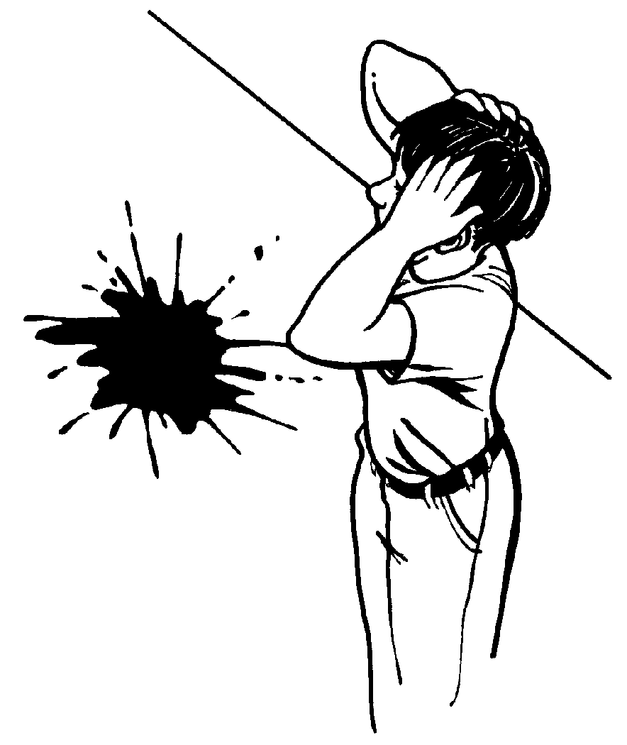
Microenvironment
Built Environment
Local
Regional
Global

Item

Our Environment
We talk about stopping Global Warming, the hole in the Ozone Layer and the reduction of the Rain Forests – we never look at the environment that we spend over 90% of our time in!
Global: The Greenhouse effect, global warming, ozone loss and nuclear waste dumping. None or very little personal influence on us.

Regional: Acid rain, deforestation and polluted farmland and rivers, this still has very little personal influence.

Local: Traffic problems, air & noise pollution, odour pollution but less than 10% of our time is spent here.

Microenvironment: This, the fourth level of the environment, the indoor or built environment. It’s our home, work place, shops, pubs etc… it’s the habitat in which we spend the vast majority of our time, in fact over 90 % of our time is spent indoors.
It’s strange, but true that we spend a lot of time on ‘saving our planet’ which is correct, however we tend to miss the fact it is our microenvironments (or built environments) that have the greatest ‘personal’ influence upon us.
We can divide our surroundings into four environments:
A treatment of PROmite™ on your soft furnishings will help you to dramatically reduce allergies in the home – however that’s not all.

PROmite™ is carried within one of the best Fluorochemical protection treatments available. This will give protection from most household soils and spills. The protection doesn’t stop at water-based spills like soft drinks, it will prevent oily stains from butter and mayonnaise.

It will make your treated fabrics and carpets look newer and cleaner for longer.

Soil will not be able to stick to the fibres – thereby making it easier to vacuum dirt away and prevent damage to the fibre.

What Will PROmite™ Treat!
⧫ Carpets  Upholstery  Mattresses
⧫ Curtains Leather  Wall fabrics

PROmite™ treatment will not stop your item from becoming dirty, although it will prevent soil and spills from sticking to the fibres thereby allowing regular cleaning and maintenance to keep the item looking newer and cleaner for longer.

Item
Stain Protection Benefits Of PROmite™
The UK government spent millions of pounds on reducing traffic pollution, but found Asthma is still affecting more and more children every year!
13
4
To enter our free prize draw or to receive a:
FREE ‘HEALTHY HOME/OFFICE AUDIT’ with no obligation to have any work carried out or for our ‘FREE CONSUMER GUIDE TO ALLERGY CONTROL’ Please phone our free consumer helpline on 0800 092 0767 and quote SelectTeam™ –or write to
ALLTEC SelectTeam™ C/O PROmite™ UK Limited, Butts farm, Fowlmere, Royston, Hertfordshire, SG8 7SL Competition deadline 1st May 2000
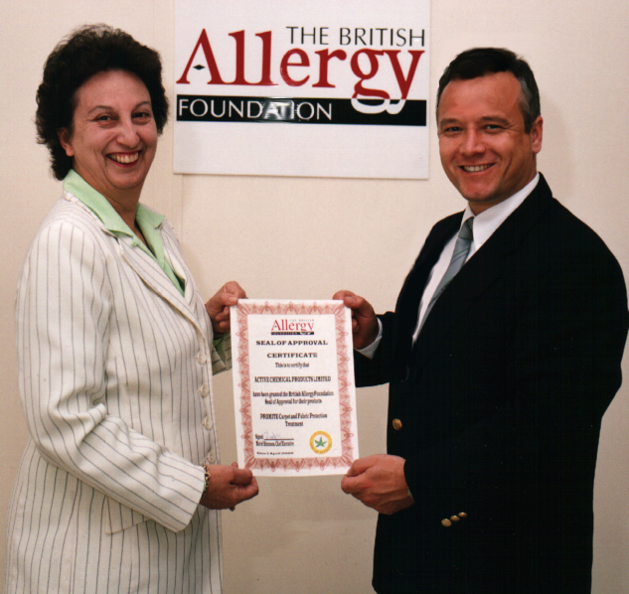
Allergy
FOUNDATION
THE BRITISH
Dust Mite Faeces

Item

The British Allergy Foundation

The British Allergy Foundation has
described ASTHMA as “One of the most significant health problems in the western world” and “The most common chronic childhood medical condition.”
Allergy’s makes life a misery for Millions in this country. Many allergy’s go unrecognised and untreated or symptoms are wrongly diagnosed. With over 40% of the population suffering from allergies, very little is being done to discover why the numbers of allergy sufferers are escalating because so few resources are allocated to research into the cause or a cure.

Most symptoms associated with allergies are so
common we don’t even realise they’re allergies
like…
Sneezing, Wheezing, Sinus pain,
Runny nose, Coughing, Rash / hives, Swelling,
Itchy eyes, ears, lips throat & palate (roof of
mouth) Shortness of breath, Sickness vomiting,
diarrhoea, and Increase in secretions.

The British Allergy Foundation (BAF) is a
Registered Charity (No. 1003726) who runs a
helpline and gives advice to allergy Sufferers
and those that wish to find out if they have an allergy.

BAF agree that a home or office is a better place with fitted carpets and soft furnishings – ‘if they are maintained correctly’.

Item
6
11
Asthma Explained!
Asthma is claimed to be hereditary –It’s NOT!
However, a baby born to an Asthmatic Mother is more susceptible to Asthma then others.
In an Asthma Sufferer the bronchi tubes become sore and inflamed due to the continued breathing in of the House Dust Mite faeces. Below are diagrams showing a cross-section of the bronchial tube. They show a normal tube (fig 1), then how the Mite Faeces attacks the inner-wall (fig 2-3) and finally a swollen bronchial tube (fig 4) as found in an Asthma sufferer – which is waiting for a ‘trigger’ to introduce an Asthma Attack.
Mucus
Layer Of Fine Hairs
Nerves
Blood Supply
Inflamed and Swollen Part of Inner Wall
Figure 1
Figure 2
Figure 3
Figure 4
Showing a normal cross-section of the Bronchi Tube.
The Protein in the faeces causes the inner wall to become inflamed and swollen.
Dust Mite faeces breaks the surface tension of the Mucus and starts to attack the inner wall.
After a long-term exposure to the Mite faeces – the Bronchi tube is swollen, buckled and reduced in size – ready for the first Asthma Attack.
Muriel Simmons, Chief Executive Officer of the British Allergy Foundation, Presents the Seal-Of-Approval Certificate to Robert Saunders, MD of ALLTEC Network in May 2000
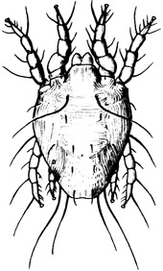
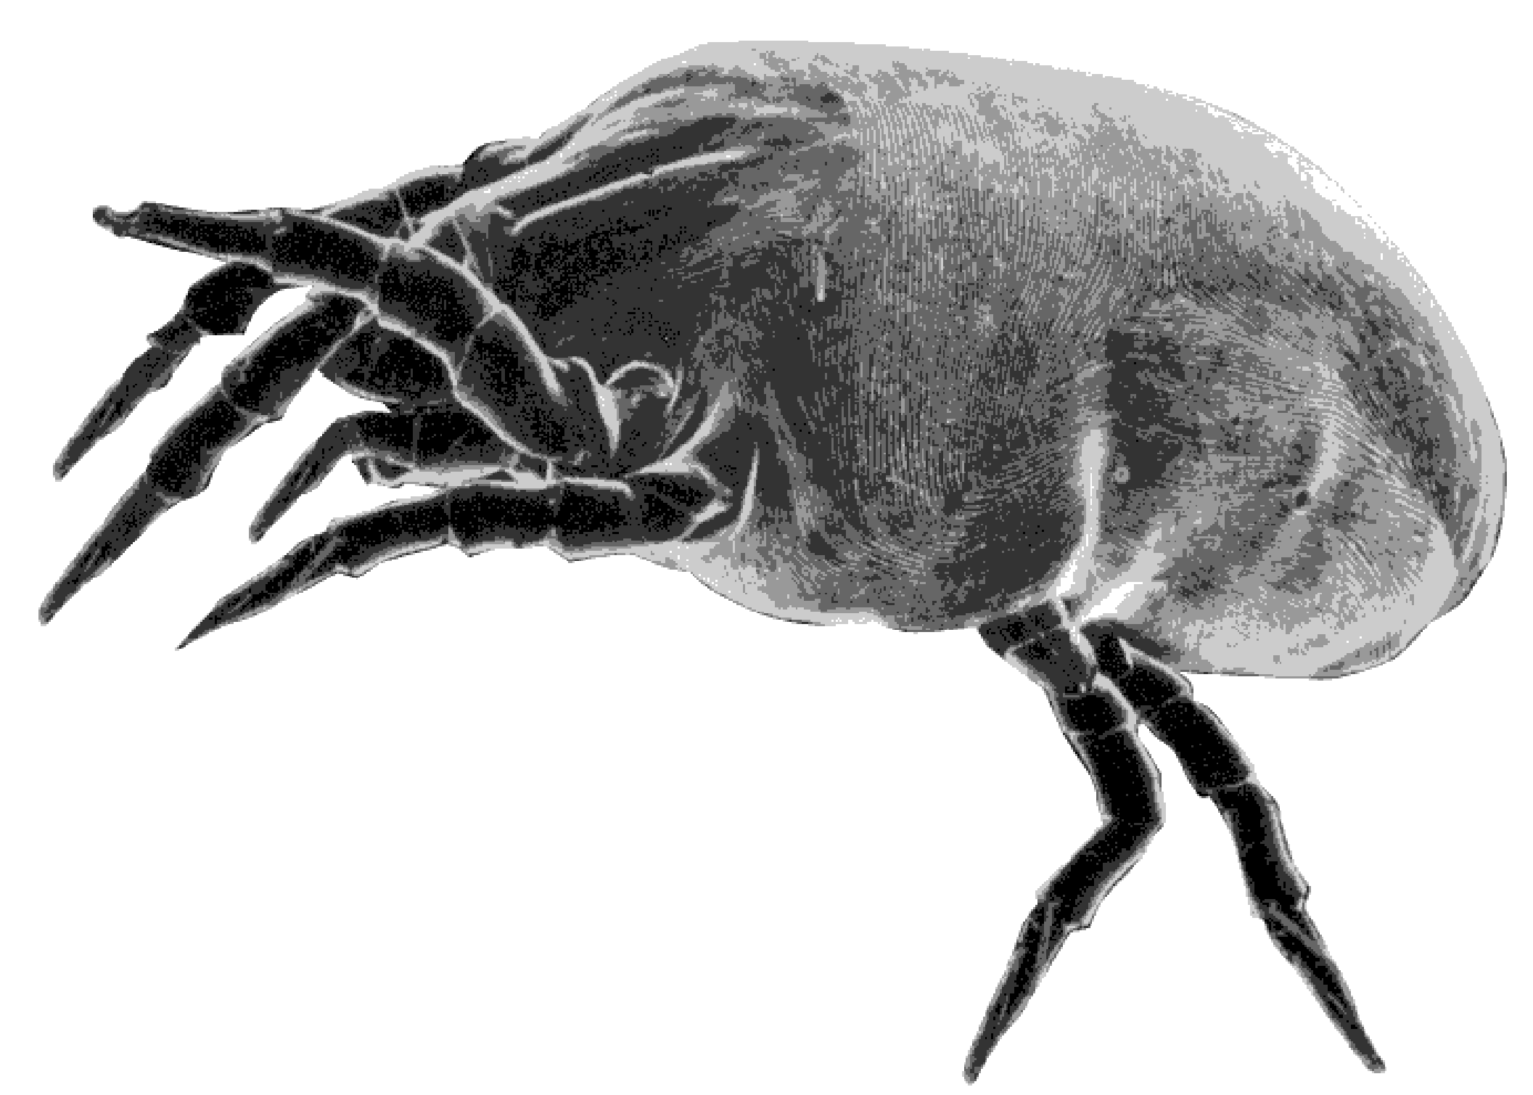

Item

Item
The House Dust Mite
Having found that Biocides were not going to be affective long-term against the House Dust Mite– they began looking in other directions.

The House Dust Mite. Or given their correct Latin title Dermatophagoides pteronyssinus are microscopic (up to 0.3 mm) arthropod creatures related to ticks and spiders. Too small to be seen with the naked eye the mites are turtle shaped creatures with eight legs. They live on the decaying dead skin flakes in house dust – skin that we shed every day. There is hardly a house in the UK without them, although the number can vary between houses containing huge numbers, and others almost none.

The Mites survival does not only depend on the amount of dust, but very much on the amount of humidity in the house. Without continuous high humidity (50+rh) their skin will cause them to rapidly dehydrate. In these perfect conditions Dust Mites live for 3-4 months with females laying 25 to 50 eggs, with a new generation produced every three weeks!

It is not the Mite it’s self that we become allergic to, ironically it’s the waste product from our skin that they digest. In fact it is the powerful protein enzymes the mites digest our skin with, in a similar way to most creatures.

Each mite will produce around 20 droppings per day everywhere they go. Each of these droppings holds around 10-12 sub pellets that are about 2-10 micron in size and contain their leftover enzymes.

8
9
It’s the enzymes which are the most important part of House Dust Mite in causing asthma and other allergic diseases to us.

House Dust Mite faeces have been a known allergy for over 30 years.

Each mite produces around 20 droppings a day.

Each dropping contains between 10-12 faeces pellets (2-10 micron in size)

Medically proven that the House Dust Mite faeces pellet is the main cause, and not merely a trigger of Asthma.

By eliminating the Mite from living in/on domestic soft furniture, especially the bedroom, it should be possible to reduce, if not eradicate Asthma in the UK.

In the UK over four million people suffer with respiratory related allergies (1 in 10 children), predominantly from effects from the House Dust Mite.

Over 2,500 people die each year from Asthma.
- The UK Health Authority spends over £750,000,000 a year on prescription drugs, just to reduce the symptoms of Asthma – not to stop or prevent Asthma.
Some reports claim that there are millions of Mites in your
bed, carpets and upholstery although we don’t agree with such a figure.

However, you can imagine if your bed held only 100 House Dust Mites and each of them produced 20 droppings per day that contained 10-12 sub pellets that’s up to 24,000 pellets per day. If you had only 1000 mites in your bed they would increase their pellets by nearly two million per week.

8 Basic Facts About The House Dust Mite
Facts About The Mite

